Observation of the Seine at Rouen with James Cook
Sunday 8 December 2019 around 12 GMT

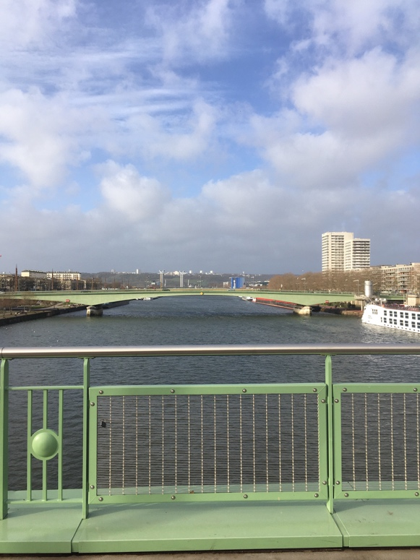

The observation was made from the Boieldieu Bridge in Rouen, named after the composer François-Adrien Boieldieu who was born in Rouen in 1775. Boieldieu composed amongst others the opera Les Voitures versées ou le Séducteur en voyage (1820).
The original bridge was painted by Pisarro in 1896. It is the exact point where the river port ends and the sea port begins.

The observation was made in the company of James Cook and eight other historical explorers, all facing west over the river Seine. On this occasion Cook recounted his astronomical observations at Tahiti in 1769 where he witnessed the Venus Transit.

The observation at Boieldieu Bridge resulted in three short films, Accident, Balance and Observation, as well as some photographs of which the further meaning still needs to be established.

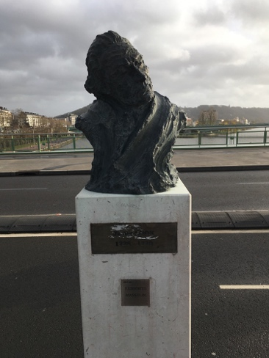
James Cook at Boieldieu Bridge in Rouen, Sunday 8 December 2019
Films link - https://we.tl/t-B6RFs1y04C

